**Data Visualization Work - A Lively Day in the Life of Hao**

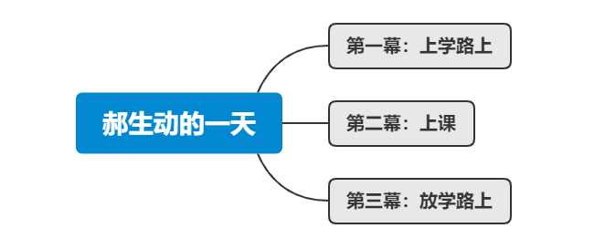数 媒 2003 班 1191200328 楚 浩 1191200326 陈春铭

**Problem Description** How can one tell a vivid story using four semesters of class schedules? The team aimed to create a visualization that was not only interesting but also reflective of daily life. This involved discussions and practical work on the form of the artwork, methods of expression, and data processing.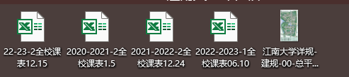

**Data Processing and Analysis**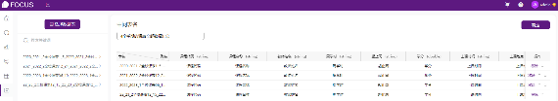

# The team used DataFocus and Excel for data processing. They imported the class schedule data of four semesters into DataFocus. The specific method involved using an intermediate table to merge the .xls course information files from all four semesters into one comprehensive table.

**Key Techniques**

**Bubble Chart Creation**: The workload of courses was measured by the total teaching hours by instructors. Using DataFocus, the team selected the attributes "Instructor Name" and "Total Teaching Hours," sorting them in descending order. This process involved summing up the teaching hours for each instructor over four semesters and arranging them in descending order based on total hours. After experimenting with bar and line graphs, the team found the bubble chart to be the most effective. Each circle in the chart represented an instructor (either an individual or a group), with the area of the circle (larger for more teaching hours) indicating the workload of the instructor. The chart was arranged in a spiral, with instructors with heavier workloads on the outer circles and those with lighter workloads towards the center.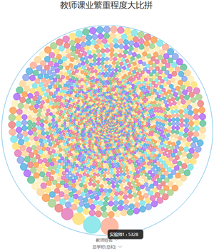

**Word Cloud Creation**: Using Python's jieba and stylecloud libraries, the team created a word cloud.

**Scatter Plot Creation**: A dictionary named 'classroom_groups' was used to store classrooms sorted by different zones. The keys in the dictionary were '1A', '1B', and '1C', each associated with a list of classrooms in that zone. The team then mapped out the classrooms, adding their locations to the corresponding lists.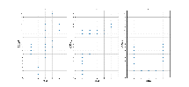

**Sunburst Chart Creation**: Using DataFocus, the team imported the attributes "Department" and "Total Teaching Hours" to calculate and rank the total teaching hours of 26 departments in descending order. They chose the sunburst chart in the "Graph Transformation" feature.

# Innovation and Creativity:

In the creation of this visualization work, we present a day in the life of a third-year college student from an immersive perspective.

Combining the provided data, we first analyzed it using software like Python and DataFocus, then produced relevant charts. Subsequently, we composed a video script integrating these elements.

The next step involved on-site filming at the school and on the way to school. After editing, we combined the previously made charts with the video.

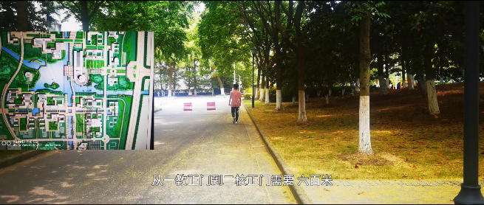Finally, we added voiceover for a third-person narrative, culminating in the completion of our visualization work.

“The sense of loss comes from not knowing when will be the last time leaving, nor where one goes after leaving. The sense of loss is about still inadvertently falling asleep in class today, or being unable to resist checking the phone. The loss is in realizing that the person he is now is not quite what he once hoped to be. He doesn’t know if his college life spanned 990 days, or just one day repeated 989 times. But fortunately, today he learned a new algorithm and met interesting people... So, he decides to keep striving, leaving everything to time. This is what Hao thinks as he reflects. “

